Search Committee Member Guide

As a “Search Committee Member,” you can:
- View postings
- View application materials
- Print application materials

Best Practices

Review and assess all applicant files using established criteria.

Maintain confidentiality of the process at all times.

Documenting why each applicant has been screened out during the process is vital to appropriate record keeping. The department or program, as well as the search committee, must be able to defend such decisions if we are subject to an audit or a complaint is filed and an investigation required.

The Process in NinerTalent

Creating a Posting / Ad on the jobs.uncc.edu website:

Reviewing of applicants and preparing for interviews:

How to Login
- Log in to NinerTalent at: URL: (http://jobs.uncc.edu/hr)
- Please note that you will be logged out of the system after 60 minutes of activity.
- If you ARE a UNC Charlotte employee, click on the “Click here to log in with your UNC Charlotte NinerNet credentials” link and use your NinerNet username and password. If you do not have access to NinerTalent, please contact us at ninertalent@uncc.edu.

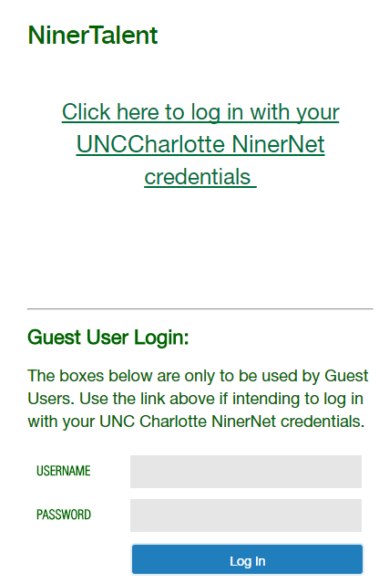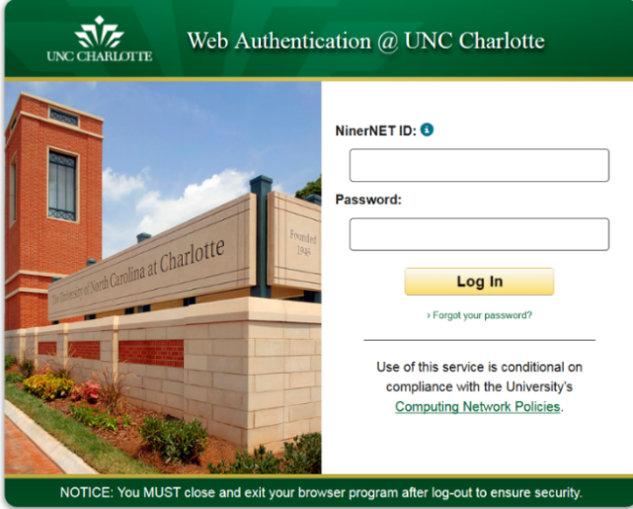
Enter your NinerNet credentials

If you are NOT a UNC Charlotte employee, you should have received an e-mail providing you with a Guest User “Username” and “Password.” Enter these and click .

- Confirm that you are in the “Applicant Tracking” module. (The top bar will be blue.) If not, click to select the Applicant Tracking module.

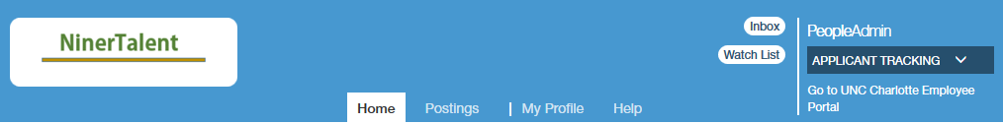

- Confirm that your user group is “Search Committee Member”. If not, click to select that user group from the “Current Group” drop down menu.
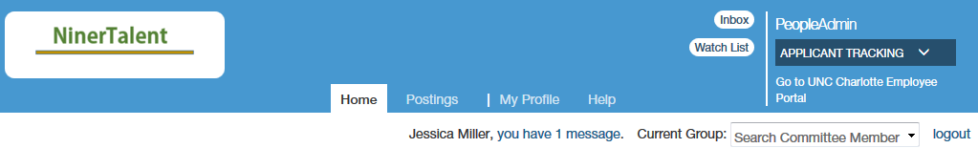

Viewing a Posting

- Hover over “Postings” and select the appropriate employee group from the drop down menu (for this example, “Faculty” will be used).
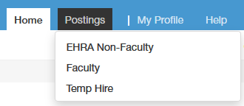
- The search results at the bottom of the screen will indicate the number of items found, which represent the number of postings for which you are a member of the search committee.
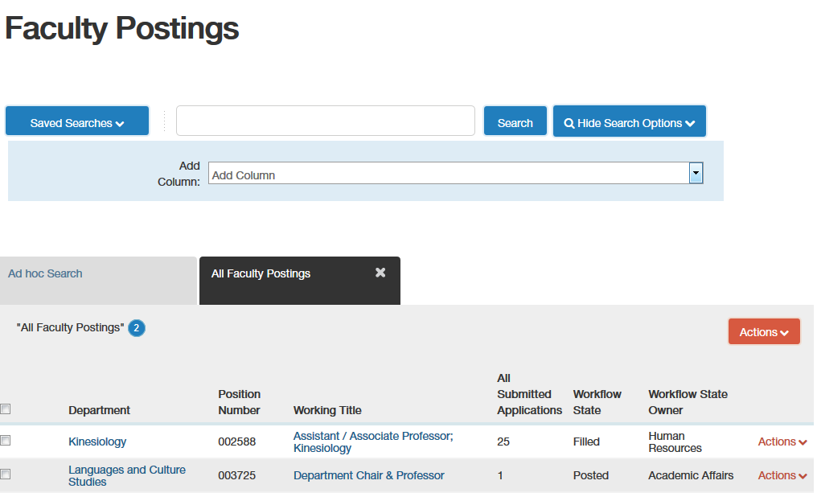

This screen may look relatively blank. However, you may add search criteria (column headings) by clicking on “More search options,”
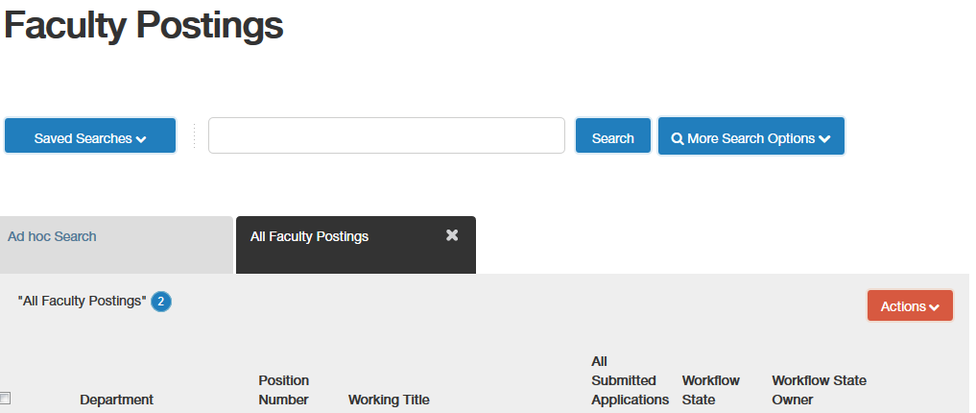

Select the column heading(s) you desire, and click “Search”. If you are on more than one search committee, you will want to add “Working Title” or “Position Number” to assist you in determining which posting you need to view.
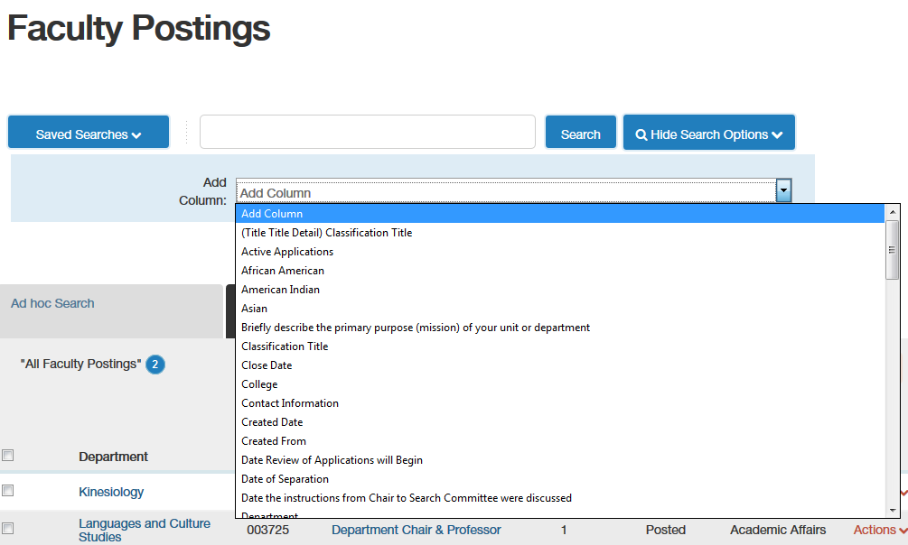

- Click Actions View Posting to view the posting for which you would like to review the Posting. Click Actions View Applicants to see the applicants for that posting. You may also share the posting on Facebook, Twitter and LinkedIn by selecting the icon.
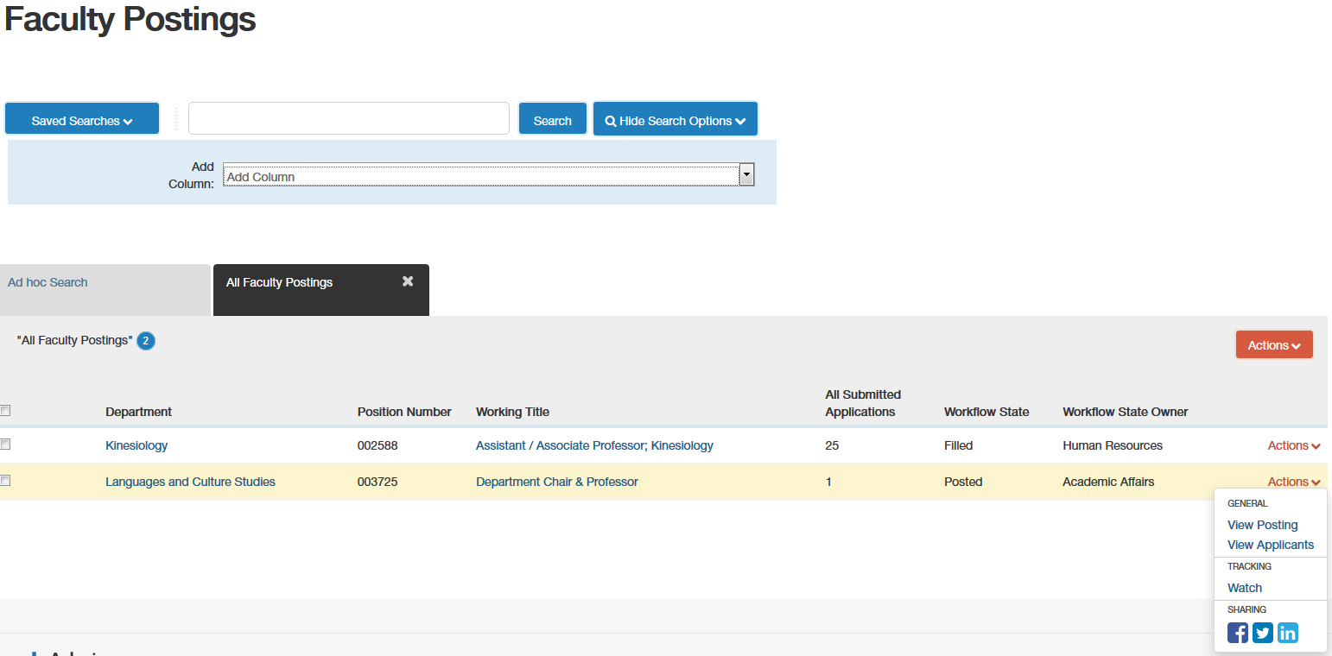

Viewing Applicants

- From the posting “Summary,” click on the “Applicants” tab.
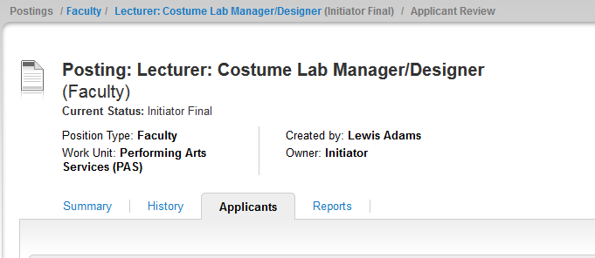
- From this screen, you can perform a variety of activities.

If you hover over the “Actions” link at the end of the row of an applicant and click on “View Application,” you can review all submitted application materials for that individual.

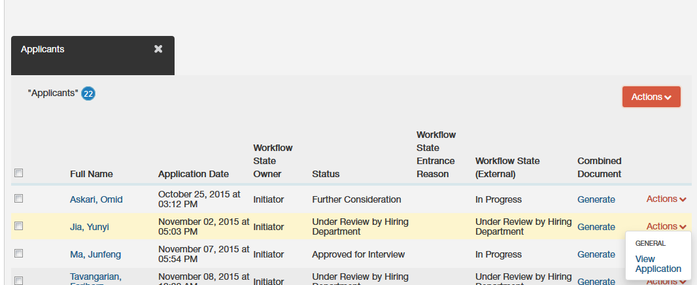

You may also view, export, or download application materials for more than one or all applicants.
Check the box next to “Full Name” for all applicants, or check the box next to selected individuals to review only those applicant materials. Hover over the inclusive “Actions” link (at the top of the last column) and select the action you would like to take.
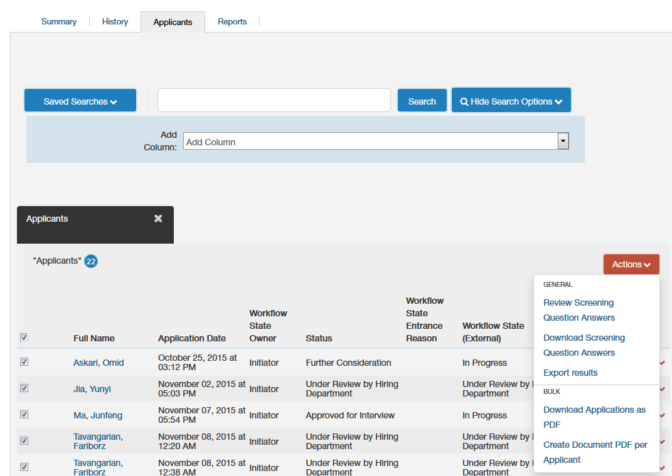

How to Print Application Materials

- Check the box next to “Full Name” for all applicants, or check the box next to selected individuals to review only those applicant materials.
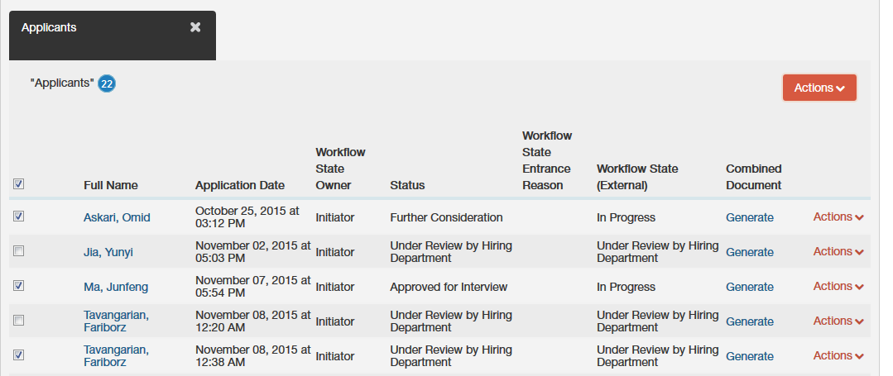
- Hover over the “Actions” button (top of the last column) and select the action you would like to take.
Downloads application materials in an individual PDF for all selected applicants
Downloads one long PDF that includes application materials for all selected applicants

Use your browser tools to print as needed.

Faculty Applicant Statuses

Allowable Status Changes | User Group who can use this status | When is the status used? | Reason Requird? | Status the Applicant Sees
Approved for Interview | Approver | The Dean approves the candidates the Department recommends for interview | No | In Progress
Declined Interview | Initiator | An applicant who was approved for interview but declined once contacted by the Department. | Yes, drop down box | Declined Interview
Further Consideration | Initiator | Short list of candidates who are qualified and may be recommended for interview and interviewed | No | In Progress
Interviewed, Not Selected | Initiator | Candidates who are interviewed but not hired | Yes, text box | In Progress
Not Best Qualified (Emails Applicant Now) | Initiator | Applicants who don't make the "Further Consideration". Don't meet minimum qualifications stated in the ad. | Yes, drop down box | No longer being considered
Offer Declined | Initiator | Candidates who are interviewed and offered the position but declines | Yes, drop down box | Offer Declined
Qualified, Not Selected | Initiator | Candidates who make it "Further Consideration" but did not get interviewed. | Yes, drop down box | No longer being considered
Recommend for Hire | Initiator | Chosen Candidate | Yes, text box | In Progress
Recommend for Interview | Initiator | Candidates who the Department would like to interview. Candidates are moved to this status for review and approval by the Dean. | Yes, text box | In Progress
Under Review by Hiring Department | Initiator | Status all candidates have once they apply to the posting | No | Under Review by Hiring Department

